How to use the
Virtual Observatory

Proper Motion of
Barnards Star
Information and contacts: http://vo-for-education.oats.inaf.it - iafrate@oats.inaf.it

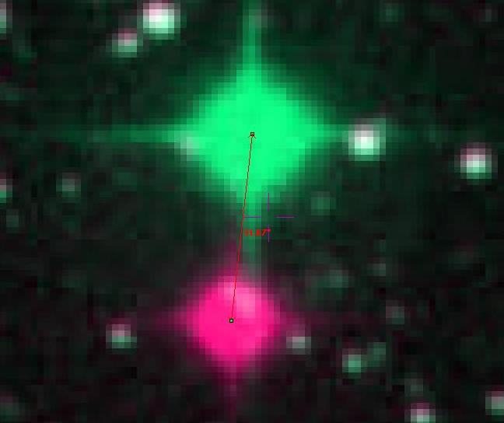

Florian Freistetter, ZAH, Heidelberg
florian@ari.uni-heidelberg.de

Our project depends on your support. If you found our material useful, we kindly ask you to acknowledge it in your publications, or to write us an email (iafrate@oats.inaf.it), or like it on our Facebook page (www.facebook.com/VOedu). Thanks!
Within this case you learn that stars that seem "fixed" on the sky may actually move, even if their motion is so slow for the naked eye to be undetectable. You compare two photographs of the Barnard's Star taken several years apart and will be able to estimate its displacement on the sky. Your estimate will be very close to actual measurements.
If used in the classroom this use case is very easy to perform and pupils can easily discover the motion of the star. However, the interpretation of the results needs an informed explanation at the intermediate level.

Stars do move!

Even if the stars are called „fixed stars“ sometime, they are not really fixed. This word was chosen in ancient times, when one did not know much about the real nature of the celestial bodies, in order to distinguish them from the „moving stars“, that change their position every night. Today we know that those are planets and that also the „fixed“ stars do move – althought their motion is very small and it took some time for the astronomers to measure it.

The rate of change of position of a star on the sky due to its real motion in space with respect tot he Sun is called proper motion. It is usually measured in seconds of arc per year.

We explicitely write „real“ motion in ordert o distinguish the proper motion from apparent motions oft he stars that are caused by Earth’s motions, e.g. the revolution of the Earth around the Sun (parallax).

A star, moving on the sky, changes its right ascension and declination at a rate given by the following formula:

where μ ist the proper motion, θ is its angle from the North direction for which θ = 0° and ist the declination (in catalogs, è is usually already corrected for ).

How fast is the Barnard Star?

The star with the fastest proper motion measured so far is Barnards Star. How fast it really is, can be found out with Aladin:

We start Aladin and then switch to undergraduate mode:

edit → user preferences → profile → undergraduate

Restart Aladin to validate the new configuration.

Open the server selector

File -> Open
Switch to tab „Aladin images“, enter „Barnard Star“ in the „target“ field and hit „submit“.

The available pictures of Barnards Star are listed. To investigate the proper motion, we chose two picture, that were made at different times. The longer in between, the better. Let's choose two images from the POSSII-Catalogue (13' x 13'). The column „date“ shows when the pictures were made. We take the images from 1991 and 1988.

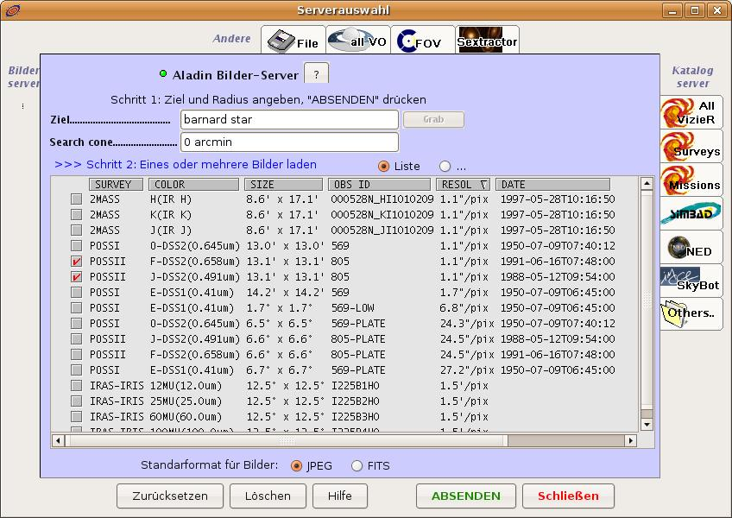Bild 1: Chosing the pictures of Barnards Star
Klick on „Submit“ to load the pictures in Aladin.

We now can combine the two images to a movie and see if the star has moved. Therefore we use the „blink“ function:

image → blink / movie generator

We specify the images we want to use and hit „create“:
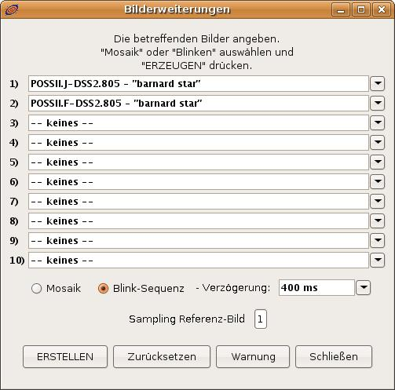Bild 2: Making a movie
To measure how far the star has moved, we use the „rgb“ function:

image → RGB image builder

This function is meant to use for the combination of images in different wavelengths to obtain a color picture. But we can use also for our case.

In the „rgb“-window, we chose one of the images for the red channel and one for the green. Klicking „create“ gives a new image
.

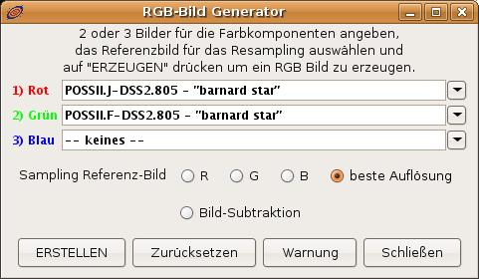Bild 3: Combining to images

The two images are now superomposed. Where the stars have not moved, they appear white. But Barnards Star has moved and thus we see two images: one in green and one in red:

We now magnify the part of the image around the Barnard Star („zoom“) and use the „dist“-tool to measure the distance between the red and the green image. The result will be approx. 32 arc seconds: that is the apparent distance that the star has moved.

But during what time? With a right-click on the images in the Aladin-stack, we can view the properties of the image. There we find the exact time, when the pictures were made:

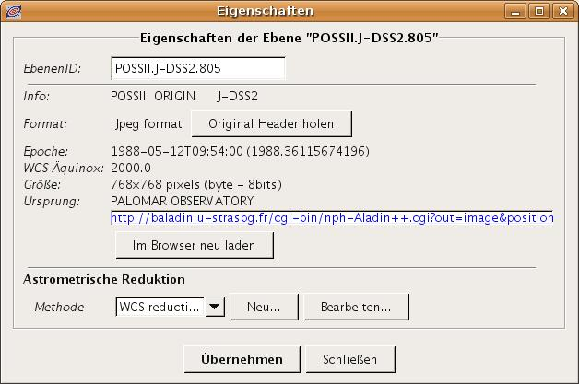Bild 4: When were the pictures made?
The relevant information can be found at the label „epoch“. In our case, the pictures were made at May, 12th 1988, 09:54:00 and June, 16th 1991, 07:47:59. Or, writen in decimals:

1988,36115674196
and
1991.45468856947.

We can now easily calculate the time that has passed during the two exposures: 3.09353182751 years.

Thus, the proper motion per year for Barnards star is 10.35 arcseconds/year!

Further Analysis

If the star moves 10.35 arcseconds per year along the celestial sphere, what is its real velocity through space? To calculate that cvalue, we have to know the distance of Barnards Star.

To obtain this information, we load a catalogue: File -> Load catalague -> Simbad Database

The catalogues symbol is now displayed in the stack on the right side. With the „mark“-tool we select the objects of the catalogue in the image and the database entries are shown in the measurement window:

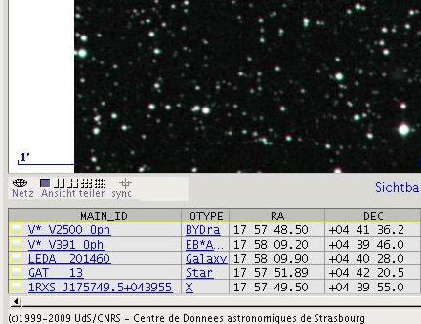Bild 5: Data from the catalogue
Barnards Star is here listed under its other name: „V* V2500 Oph“ („V“ means „variable“ since Barnards Star is a variable star). Klicking on its name opens the Simbad-Database in the webbrowser where one can fand all relevant data:
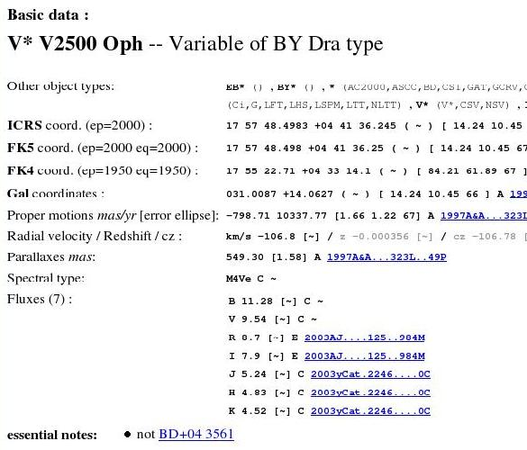Bild 6: Barnards Star at Simbad
„Parallaxes mas“ indicates the parallax of the star in milliarcseconds (mas). It is given as 0.549 arcseconds

We now can calculate easily the distance r to Barnards Star:

r = 1 / 0.549 = 1.82 pc

We now known, that Barnards Star is 1.82 parsecs away and shows an apparent motion of 10.35 arcseconds per year.

Simple trigonometry gives the real distance, that Barnards Star covers in a year:

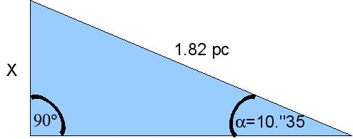Bild 7: Trigonometry

The distance X that the star moves during a year is 0.0000912 parsec or. 2813000000 km. That corresponds to a tangential velocity of 90 km/s or 321000 km/h.

Motion on the celestial sphere

The visible motion of Barnards Star on the sky is also influenced by other factors: the motion of the earth around the sun; the influence of the moon on the motion of the earth, etc.

The APFS-toll of the german virtual observatory (GAVO) allows a visualistaion of the real motion of a star on the celestial sphere
It can be accessed at http://dc.zah.uni-heidelberg.de/apfs/res/apfs_new/hipquery/form.

Enter „Barnard Star“ in the „Object“ field and specify the timescale. Lets look at the motion between June 1st 2009 and June 1st 2014. The output interval („interval of generation“) should be 24 hours. As „output format“ we choose a graphical represantation and select „VOPlot“.

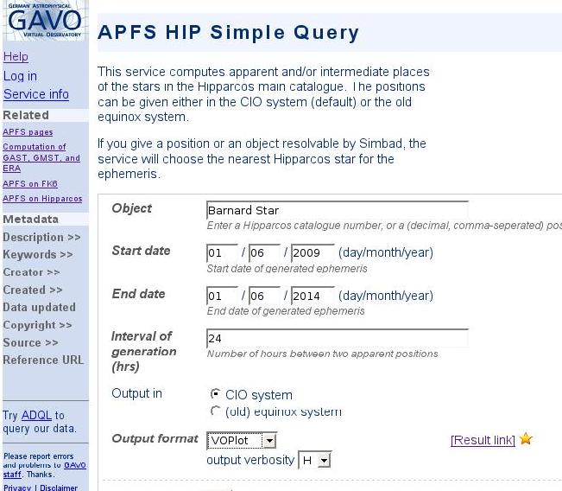Bild 8: Motion of Barnards Star with GAVO
Clicking „Go“ starts the calculation and the graphical user-interface.

There we have to adjust the correct columns for „x“ and „y“. We want to have the right ascension („raCIO“) at „x“ and the declination („dec“) at „y“. A click on „plot“ draws the new image.

We can now see how the position of the star is changing during time. There are five loops that correspond to the five years from 2009 to 2014 and are due to the motion of the earth around the sun. The superimposed linear motion from the lower left to the upper right is the real proper motion of the star:

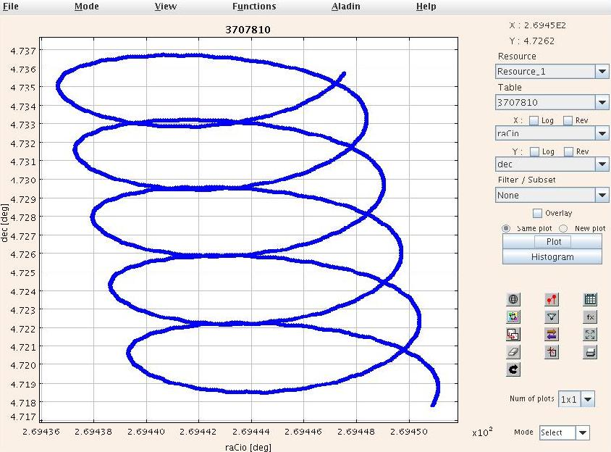Bild 9: Motion of Barnards Star
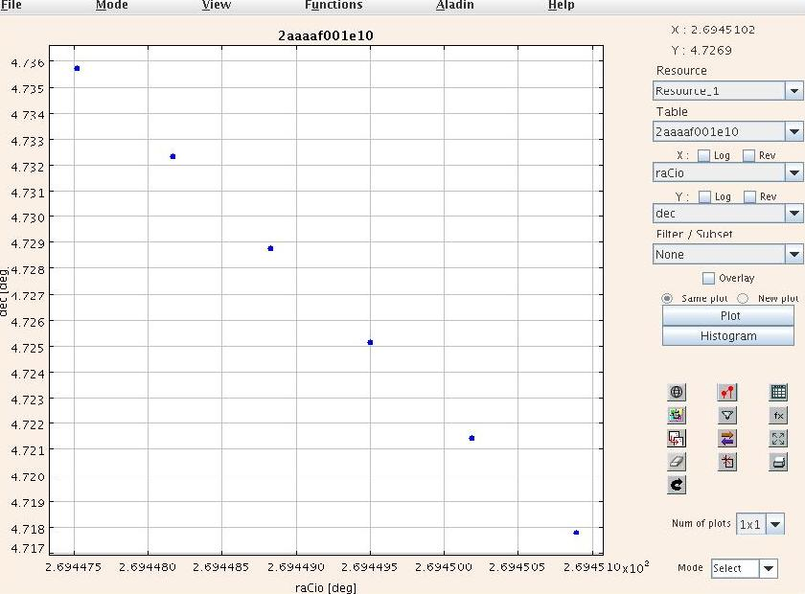Bild 10: Motion of Barnards
That gets more clear, if we change the output interval from 24 hours to 8766 hours (one year). The motion of the earth is now filtered out and we can see the linear proper motion of Barnards Star:

