
How to use the
Virtual Observatory

The Distance to
Andromeda

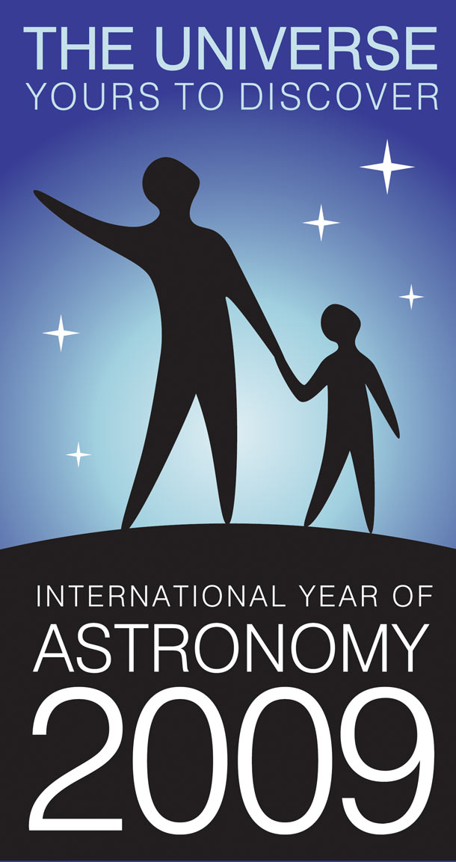
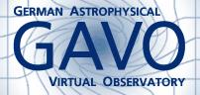
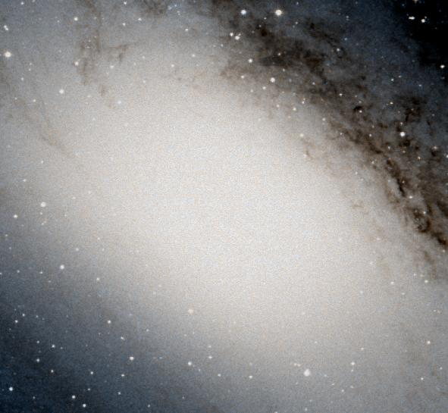
Information and contacts: http://vo-for-education.oats.inaf.it - iafrate@oats.inaf.it

Florian Freistetter, ARI Heidelberg

Our project depends on your support. If you found our material useful, we kindly ask you to acknowledge it in your publications, or to write us an email (iafrate@oats.inaf.it), or like it on our Facebook page (www.facebook.com/VOedu). Thanks!

Within this advanced use case you measure the linear distance of the Andromeda Galaxy following the steps of the astronomers who first measured it, climbing an important step of the so-called cosmic distance ladder. The use case requires the identification of variable stars of the Cepheid class and the determination of the relation between their period and their intrinsic luminosity.

If used in the classroom this advanced use case requires good mathematical skills since it is necessary to compute logarithmic and exponential functions. The use case is therefore suggested for students at college level.

Introduction

Measuring the distances to other celestial objects is difficult. For near objects, like the moon and some planets, it can be done by sending radio-signals and measure the time it takes for them to be reflected back to the Earth. Even for near stars it is possible to get quite acurate distances by using the parallax-method.

But for distant objects, determining their distance becomes very difficult. From Earth, we can only measure the apparant magnitude and not how bright they really are. A small, dim star that is close to the Earth can appear to look the same as a large, bright star that is far away from Earth.

As long as the early 20th century it was not possible to resolve this major problem in distance determination. At this time, one was especially interested in determining the distance to the so called „nebulas“. One has found many of this diffuse looking objects in the sky. Some astronomers thought them to be clouds of gas inside our milky way. Others believed, that there wer islands full of stars, galaxies of their own and at extremly large distances. If this would be true, our universe would be much more larger than previously thought.

But without a way to determine their distance, it was not possible to resolve this debate. The first hint on how the measure their distance came from Henrietta Swan Leavit. In 1912 she investigated a group of variable stars called „Cepheids“. Those stars change their brightness periodically over some days. Leavitt found that the period of the luminosity variations is connected to the absolute magnitude of the star! If one thus knows the period P of a cepheid, one can use the following formula to determine the absolute magnitude M:

M = -1.43 – 2.81 * log (P)

(P is measured in days)

One now knows how bright the star really is an can compare that value with the apparent magnitude m, which can be easily measured. Knowing, how bright the star is and how bright he appears, one can use the so called distance modulus:

m – M = -5 + 5 log r

where r is the distance of the object measured in parsec (1 parsec is 3.26 lightyears or 31 trillion kilometers).

With this method, in 1923 Edwin Hubble was able to observe Cepheids in the Andromeda nebula and thus determine its distance: it was indeed an object far outside the milky way and an own galaxy!

Measuring the distance to Andrimeda with Aladin

In this usecase we use Aladin in the undergraduate mode (developed in the framework of the EuroVO-AIDA European project).
Start Aladin (available for free here: https://aladin.u-strasbg.fr/java/Aladin9.0.jar) and switch to the undergraduate mode from the menu:
edit -> user preferences -> profile -> undergraduate.
Restart Aladin in order to validate the new configuration.
To measure the distance to Andromeda with Aladin, one first needs observational data. To make use of the Period-Brightness-Relation, we search the Virtual Observatory (VO) for data on cepheids in the Andromenda galaxy:

File -> Open, then choose „ViZieR“ from the „catalog server“ menu

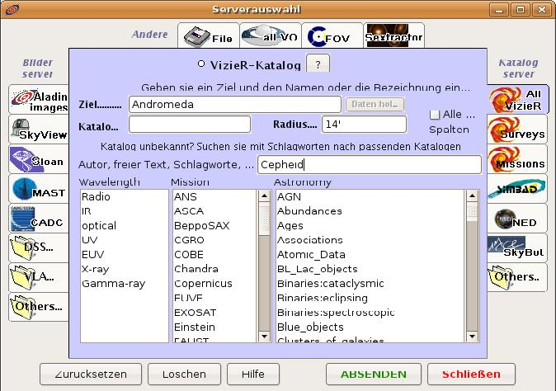Image 1: Searching the VO for cepheid data.
In the form field, enter „Andromeda“ (or „M31“) as the „target“. Since we do not lnow in which catalog we can find our data, we enter „cepheid“ in the field for „free text“. Klicking on „Submit“ will start the search.

We will obtain three catalogs as our result (the field „description“ contains more information about the data):
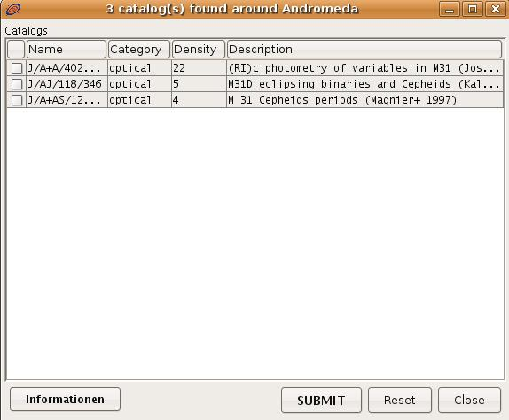Image 2: 3 catalogs were found

We chose the most recent catalog from 2003. In the main window of Aladin, we will now see the position of the objects in the catalog; in the stack on the right we can see the symbol of the catalog „J.A+A 402.113):

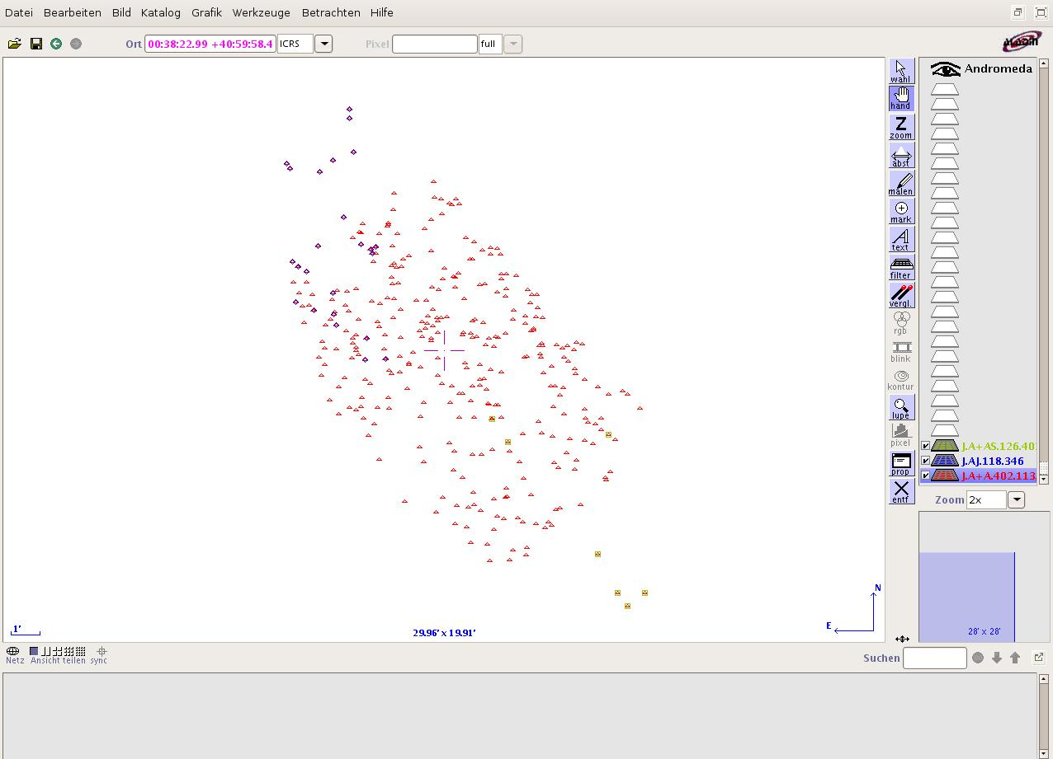Image 3: A catalog was loaded
In the next step, we want to examine the catalog data in more detail. We select the „select“-tool from the toolbar menu on the right side of the Aladin window and mark all the objects. In the measurement window (below the main window) we can see the data from the catalog:
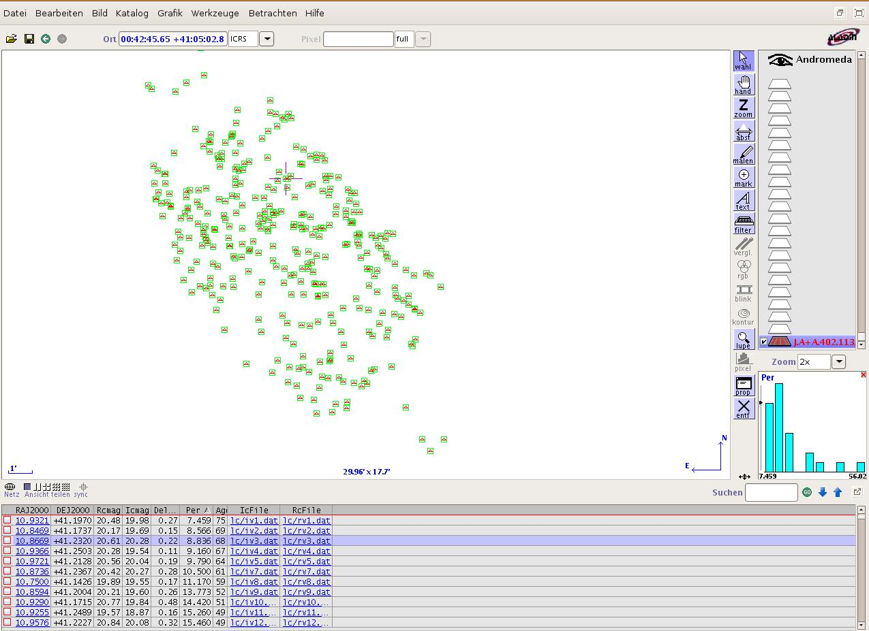Image 4: Displaying the catalog data
„ID“ gives the Identifier of the star; „RAJ2000“ and „DEJ2000“ are the right ascension and declination of the star. „Rcmag“ and „Icmag“ are the apparent magnitudes of the stars in different filters. „DeltaRc“ is the error bar of the measurement and „IcFile“ and „RcFile“ link to the detailed Lightcurves of the stars.

The column labeled „Per“ gives the Period of the star and is the one we are interested in. But looking at the complete list of objects, we notice, that not all contain values for the period. To display only the stars for that peroids were measured, we can define a special filter:

Catalog -> Create a new filter

There we change to the „Advanced mode“ and chose „Per“ from the „Columns“-menu.
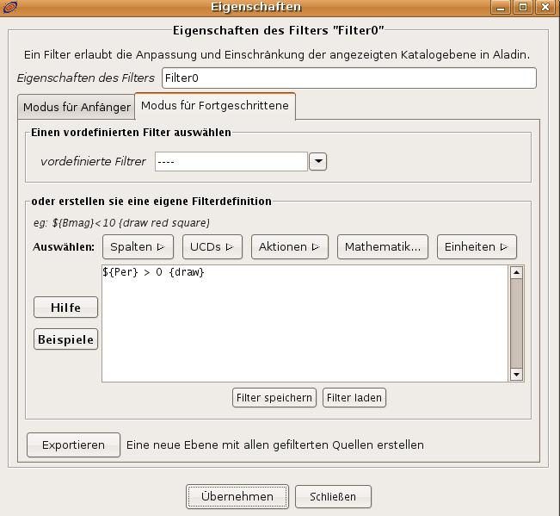Image 5: Creating a filter
In the filter-window, we will see the term „${Per}“. Since we only want the objects, where a Period exists, we change this to „${Per} > 0“. To draw those entries in the Aladin window, we add a last modification: „${Per} > 0 {draw}“. Klicking „apply“, the filter is activated and in the main Aladin window we will now see just the stars with a known period.

We now use the period-brigtness-relation to calculate the distance to the stars.

First, we create a new column in the catalog:

Catalog -> Add a new column

In the „Column calculator“-window, we first enter a name for the new column, e.g. „M“, the traditional label for the absolute magnitude (we can ignore the fields for UCD and unit).

We now have to specify how the new column has to be calculated. In the field expression, we enter the formula for the period-brightness-relation:

- 1.43 - 2.81 * log(${Per})

Klicking on „Add new column“ performs the calculation and displays the new column.

We now need an aditional new column where we calculate the distance, using the distance modulus.

Thus, we repeat the procedure and now use the expression

10^((${Icmag} - ${M}+5)/5)*3.26

The multiplication with 3.26 converts the output from parsec directly to lightyears. The measurement-window in Aladin now shows the distance of all the cepheids.

Note that this method is a relatively crude one. To obtain exact results, one has to fine-tune the constants in the period-brightness-relation to the filters used in the luminosity-measurements.
But if one calculates a mean-value of all the distances, we obtain a quite good result: the Andromeda galaxy has a distance of 2.52 +/- 0.14 million lightyears!

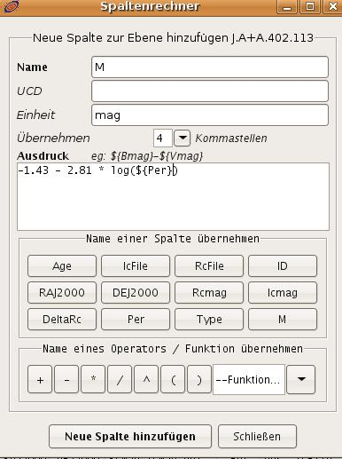Image 6: Calculating a new column in the catalog

