
How to use the
Virtual Observatory

Astronomy for preschools
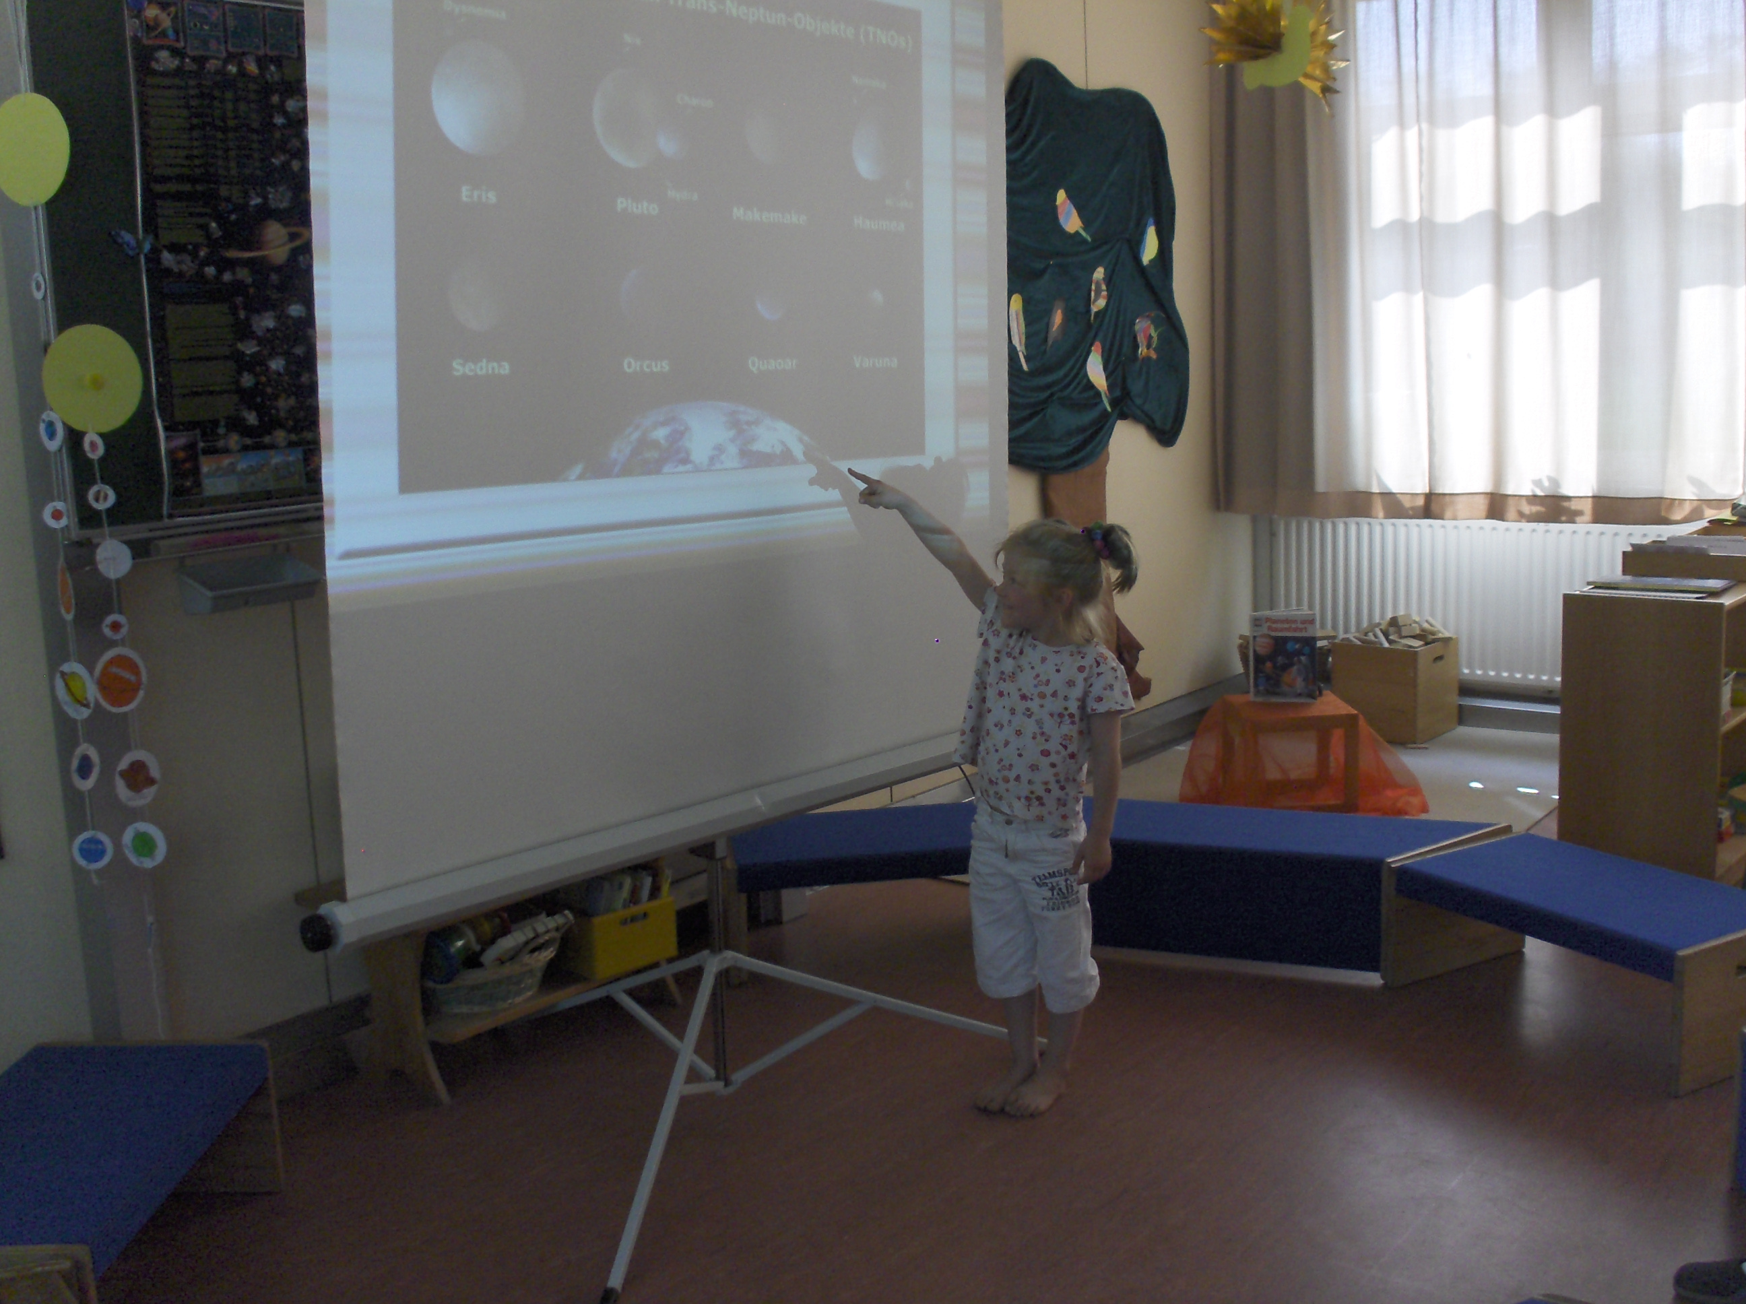
Information and contacts: http://vo-for-education.oats.inaf.it - iafrate@oats.inaf.it

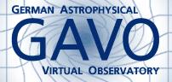
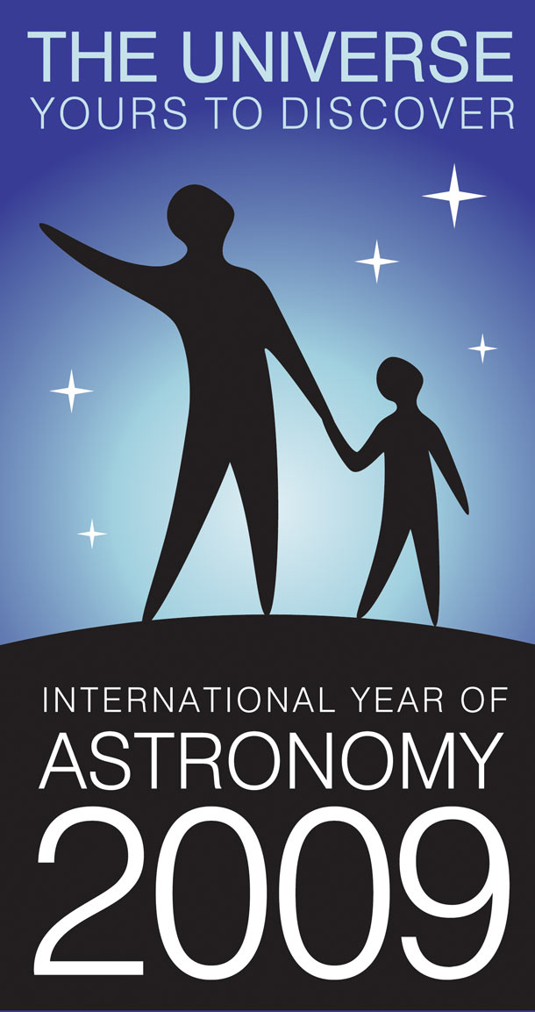
Florian Freistetter, ZAH, Heidelberg
florian@ari.uni-heidelberg.de

Our project depends on your support. If you found our material useful, we kindly ask you to acknowledge it in your publications, or to write us an email (iafrate@oats.inaf.it), or like it on our Facebook page (www.facebook.com/VOedu). Thanks!

Within this use case you will be shown the easiest and most appealing functions of the software Stellarium for a presentation to preschoolers. Main topics are constellations and their variation between different cultures. Light pollution is mentioned too.
If used in the classroom this basic use case is very simple but it should be performed by a teacher.

Introduction

The Virtual Observatory (VO) is not only a valuable tool for professional astronomers but also very useful for outreach and education. Up to now, the focus was on teaching the VO in schools and universities. The VO makes it possible to visualize and demonstrate many basic principles of astronomy, the students can learn with real astronomical data and get a taste of scientific working. But the sky, the planets and the stars are not only interesting for students – also the very young kids are fascinated by astronomy and the VO makes it possible to introduce them to some basic phenomena. Using the program „Stelllarium“ we will show how some fundamental properties of the sky can be experienced by kids in kindergarten or preschools.

Stellarium

„Stellarium“ (http://www.stellarium.org) is a free software that simulates the sky and the motion of the celestial bodies. One can specify any location on Earth, any time in future or past and see how the sky will look at that moment. Thus, after starting the program, one has to specify the location to use. This is possible in the „Location“ window – select it from the menu on the left or press „F6“. You can now select a place from a large database or directly enter some geographical coordinates.

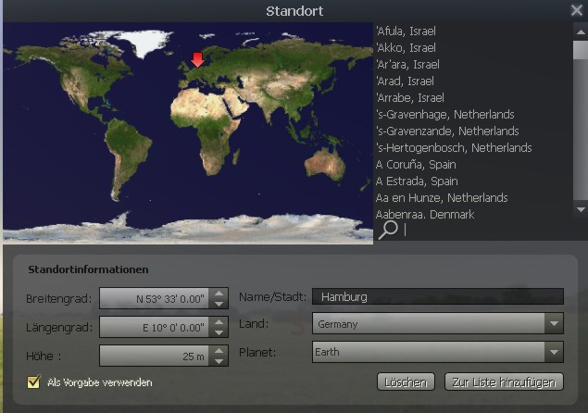Figure 1: Choose a location
In the „Date/Time“ („F5“) window you can enter the desired time. Now you see how the sky looks like at your place and your time. The motion of the celestial objects appears in real time. Thus, if you would observe the screen for 24 hours, you would see the Sun rise, set and rise again. But of course you sometimes will not like to wait that long and thus it is possible to speed up time or reverse it by using the control buttons:

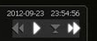Figure 2: Controlling time
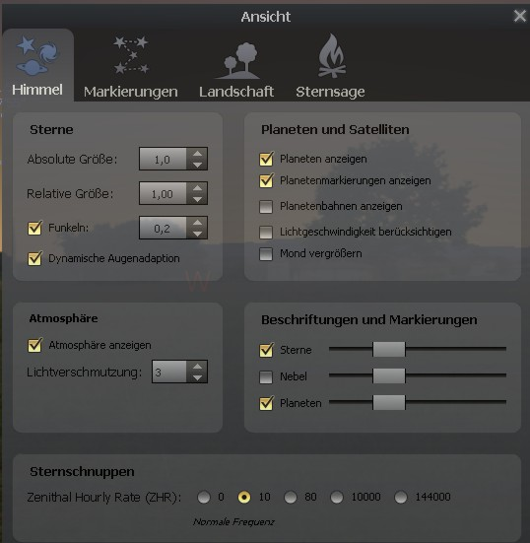Figure 3: View-Options
If you want to know where a certain object is on the sky just press „F3“ or choose the „Search“ option from the menu. If you press „F4“ or select the „View“ window you can specify in detail how the sky should be presented.
You can specify how large the stars should appear („relative scale“) and how many you want to see („absolute scale“). You can turn-off the effect of the atmosphere which diffuses the light of the Sun and makes the sky to appear blue. Without atmosphere we would be able to see the stars also during the day. You can view the planets and their orbits and let Stellarium show you some shooting stars. It is also possible to draw the lines of the constellations in the sky or view some artistic representations. You can also read about the stories and myths behind the constellations and let Stellarium display the constellations of other cultures.
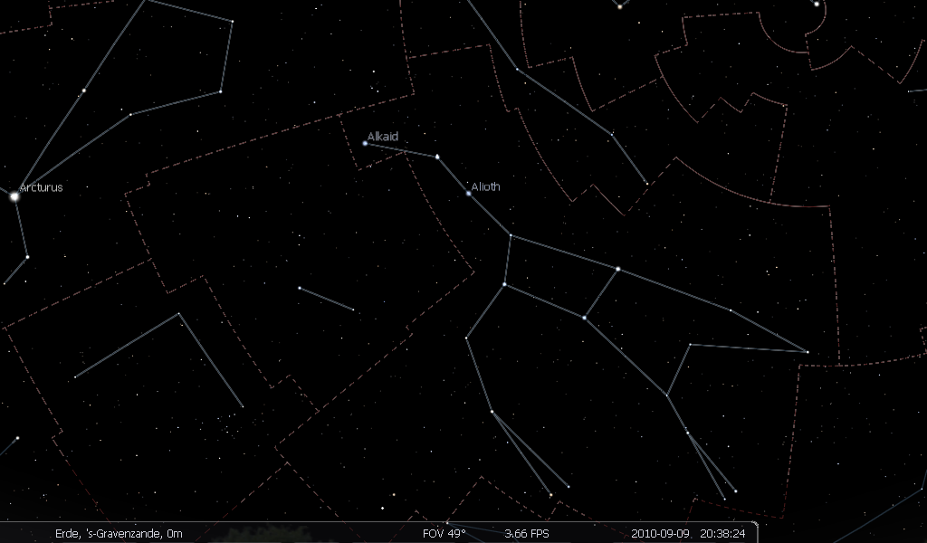Figure 4: Constellations with lines
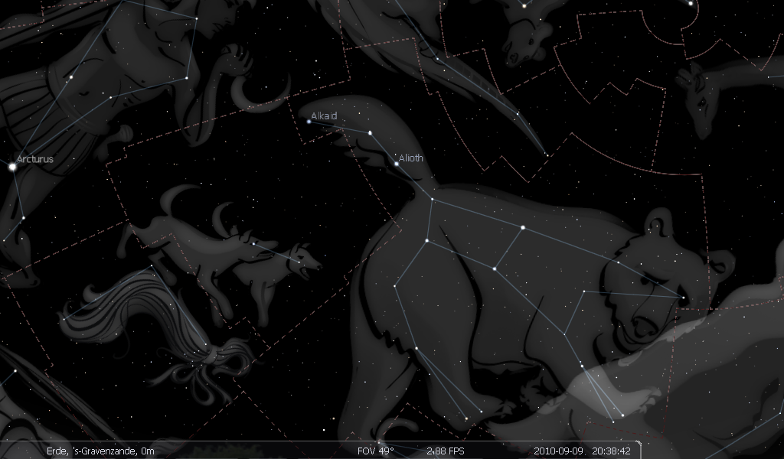Figure 5: Constellations; artistic

Stars and Constellations

This function is an ideal tool to get children to know the constellations on the sky. One starts with a „blank“ sky, a sky with no lines or other markings; just stars. This image can be projected on a large screen and the kids can try to identify some patterns or find some images. Which images will they see in the sky? They can draw their own constellations and compare them later with the real ones that now can be shown in Stellarium.
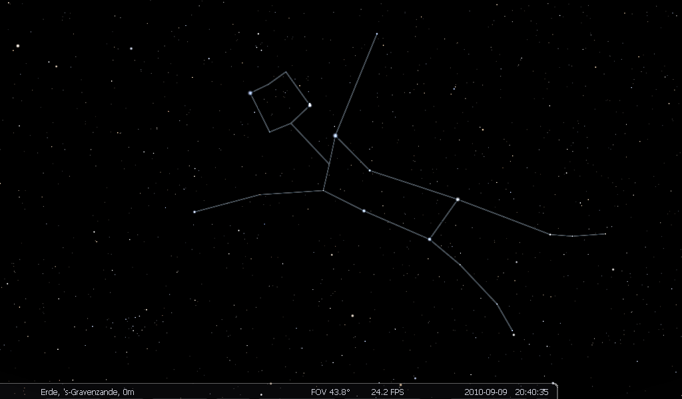Figure 6: The „turning man“ of the Navajo

How will find the dipper in the „Big Dipper“? Who will see the stars as cart or as cap? Is there anyone who has seen a bear like the people in ancient times that named this constellations „Ursa Majoris“ (Great Bear)? Other cultures have seen something completely different. The Navajo indians of America connected the stars of Ursa Major in a completely different way and found some dancing people, while the Inuit of the arctic named this constellation not a bear but a caribou.

If you show the constellations in Stellarium and let the time go fast one can demonstrate how the stars seem to move during the night because of the motion of the Earth. It is well visible that some constellations – like Big Dipper – will always be on the sky during the night and never set. And all the stars and constellations turn around the celestial north pole near polaris.
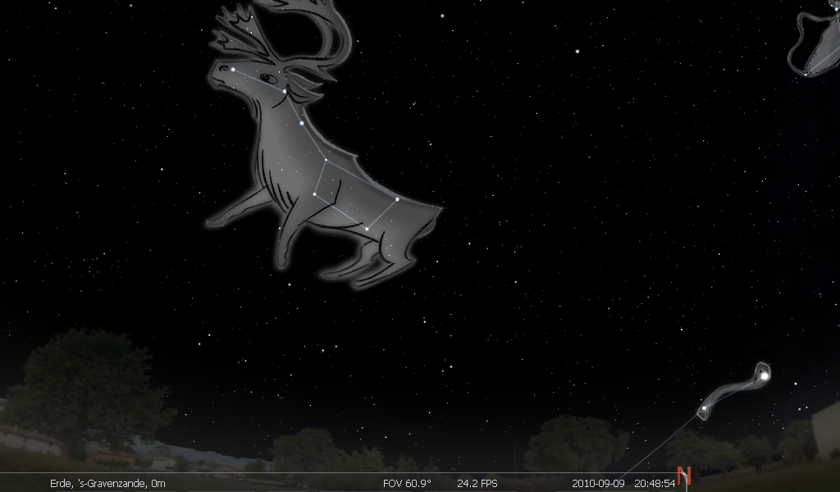Figure 7: The caribou of the Inuit
Light Pollution

After watching the stars on the sky of Stellarium one can ask the kids if they have ever seen such a sky in reality. Most of the children will live in urban areas where the light from the cities makes the night sky less dark and only some few stars are visible.

Stellarium allows one to demonstrate the effects of this light pollution (which not only is bad for astronomers but also for many animals and plants). Open the „View-Options“ (“F4”) and you will find the possibility to specify the amount of light pollution on a scale from 1 to 9. 1 is the darkest sky possible and 9 an extremely polluted sky like it is found in today cities. Stage 1 and 2 are found nowhere in middle Europe and other densely populated areas, to see a sky of stage 3 one has to travel far away from all cities. The „normality“ for most people is stage 8 or 9.. By showing the sky with different amounts of light pollution one can demonstrate this problem to the kids and show them that the stars they normally see on the real sky is by far not everything that the sky has to offer.
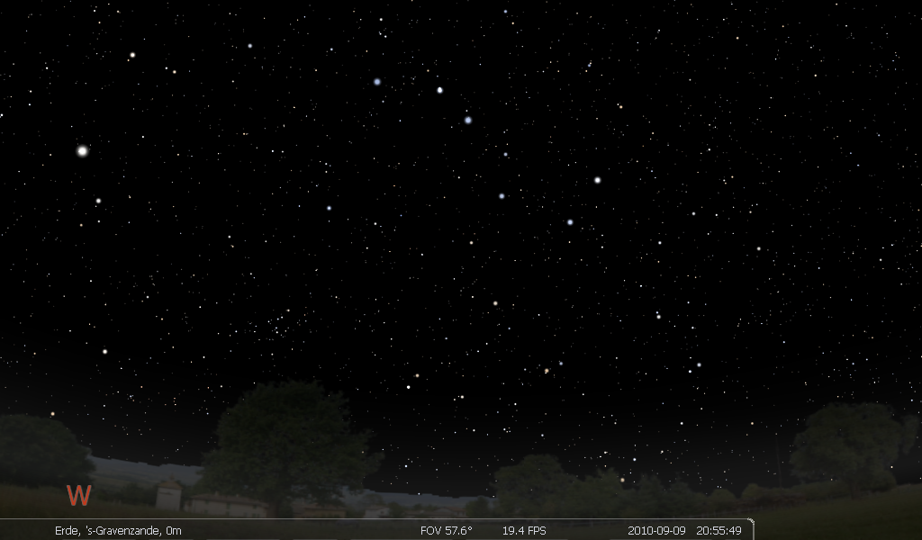Figure 8: Dark ky
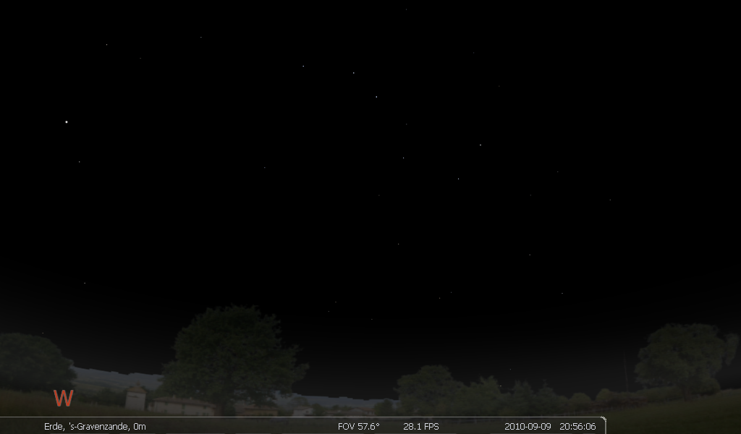Figure 9: Polluted sky
Other Possibilities

Stellarium offers lots of other possibilities to demonstrate celestial phenomena. One can show how the planets are different from stars by their fast motion over the sky and how the artificial satellites are even faster. Or one can demonstrate how the view of the sky changes with different locations on Earth or different seasons. In the internet, one finds many other examples for demonstrations (just follow the links from stellarium.org).

