CoSADIE

**THE MASS OF JUPITER**

G. Iafrate, M. Ramella

INAF - Astronomical Observatory of Trieste

Information and contacts: **http://vo-for-education.oats.inaf.it** - **iafrate@oats.inaf.it**

*Within this use case you determine the mass of Jupiter by observing the orbits of the Galileian moons and by inserting these data into Kepler's laws (use case 12.).*

*If used in the classroom this intermediate use case requires an introduction to the basics of gravitation, simple algebra and knowledge of the scientific notation for physical quantities. Its content is interesting also for students at college* level.

**1 Introduction**

Jupiter is the major planet of the Solar System: its mass is more than 300 times the mass of Earth and its volume is more than 1000 times the volume of our planet.

Jupiter is surrounded by at least 67 natural moons and a thin set of rings (too faint to be seen in most images): it is the planet of the Solar System with the largest number of moons!

The sizes of most moons are too small to be observed with small instruments, but four are large enough. These four moons - Io, Europa, Ganymede and Callisto - are often called the Galileian moons because the Italian astronomer Galileo Galilei discovered them in 1610 shortly after he first turned his telescope toward the sky.

Few years after the discovery of the moons of Jupiter, Kepler announced his third law on planetary motion: *the square of the revolution period of the planets is proportional to the cube of the semi-major axis of their orbit*. Kepler’s third law applies to the planets of the Solar System but, in its more general version, also to moons of a planet, allowing us to compute the mass of a planet by observing one or more of its moons.

In this use case we compute the mass of Jupiter by studying the orbits of the Galileian moons: we obtain their semi-major axis and revolution period from Stellarium and then use these data in Kepler’s third law.

**2 Jupiter**

Jupiter’s orbit is the fifth largest of the Solar System. It is a gas giant as Saturn, Uranus and Neptune.

Jupiter has a chemical composition similar to the Sun: it is made mostly of hydrogen and helium with a small fraction of other elements.

Due to its size and composition, Jupiter is considered a “failed star”: if it had a mass 80 times greater, it would have the right pressure and temperature conditions to start nuclear reactions and became a star.

**3 Kepler’s laws**

The orbits of planets and of their moons, of asteroids and of comets are governed by the gravitational force and described by the three Kepler’s laws (published between 1610 and 1618):

*First law*: the orbit described by a planet is an ellipse and the Sun occupies one of the two foci.

*Second law*: the vector joining the planet and the Sun describes equal areas in equal times.

*Third law*: the square of the revolution period of a planet is proportional to the cube of the semi-major axis of its orbit.

When Kepler discovered his third law, he knew only that it applied to the orbits of planets around the Sun. However, the third law turns out to apply much more generally: for example, it works for asteroids and comets as well planets and their moons. Kepler’s laws find their explanation within Newton’s general theory of gravitation.

The Newton’s version of Kepler’s third law relates the orbital periods, distances, and masses of any pair of orbiting objects, such as the Sun and a planet, a planet and a moon, or two stars in a binary star system.

Mathematically, we can write it as:

$$P^{2}=\frac{4π^{2}}{G\left(M_{1}+M_{2}\right)}⋅a^{3}$$

where *M*1 and *M*2 are the masses of the two objects, *P* is their orbital period, *a* is the semi-major axis of the orbit and G is the gravitational constant.

If one object is much more massive than the other, we can ignore the mass of the smaller one. For example, in the case of a planet orbiting the Sun, the sum *M*planet + *M*sun is just *M*sun because the Sun is so much more massive than any of the planets. Thus, knowing any planet’s orbital period and distance from the Sun allows us to calculate the mass of the Sun.

**4 Stellarium**

Stellarium is a free software that transforms a home computer in a planetarium. It calculates the positions of Sun and Moon, planets and stars, and draws the sky how it would be seen from an observer anywhere on the Earth and at any epoch. Stellarium can also draw the constellations and simulate astronomical phenomena such as meteor showers and solar or lunar eclipses.

Stellarium may be used as an educational tool for kids of all ages, as an observational aid for amateur astronomers wishing to plan an observing night, or simply to explore the sky (it is fun!). Stellarium shows a realistic sky, very close to what you see with naked eye, binoculars or telescope. Stellarium gives astronomical data (coordinates, magnitude, distance, etc.) of most of the celestial objects visualized on the screen.

You can freely download Stellarium from our site http://vo-for-education.oats.inaf.it or from http://www.stellarium.org.

**5 Compute the mass of Jupiter**

First, we need to measure the semi-major axis and the revolution period of one or more of Jupiter’s moons. In this use case we work with “Io”.

We start Stellarium, in order to see (and follow) Jupiter and its moons also when they are below the horizon or during the day we turn off the effects of atmosphere (button “atmosphere” - ) and the visualization of the ground (“ground”- ). For a better visualization, we turn off also the cardinal points (button “cardinal points” - ) and the fog (F key).

We find Jupiter and fix it at the center of the screen: push the space bar on the keyboard or the button “centre the selected object” -  in the bottom menu. We zoom in until we see the four Galileian moons and identify Io (fig. 1).

Stellarium lets us move forward and backward in time, using the arrows () at the right of the bottom menu. By clicking (more than once) on the button with the left or right double arrow, the time is accelerated. In this way we can have a quick view of phenomena lasting many hours. The button “play - ” brings back the flow of time to its standard rate.



Fig. 1: Jupiter visualized in Stellarium together with three of the four Galileian moons. The arrow indicates Io.

Switch from azimuthal mount to equatorial mount (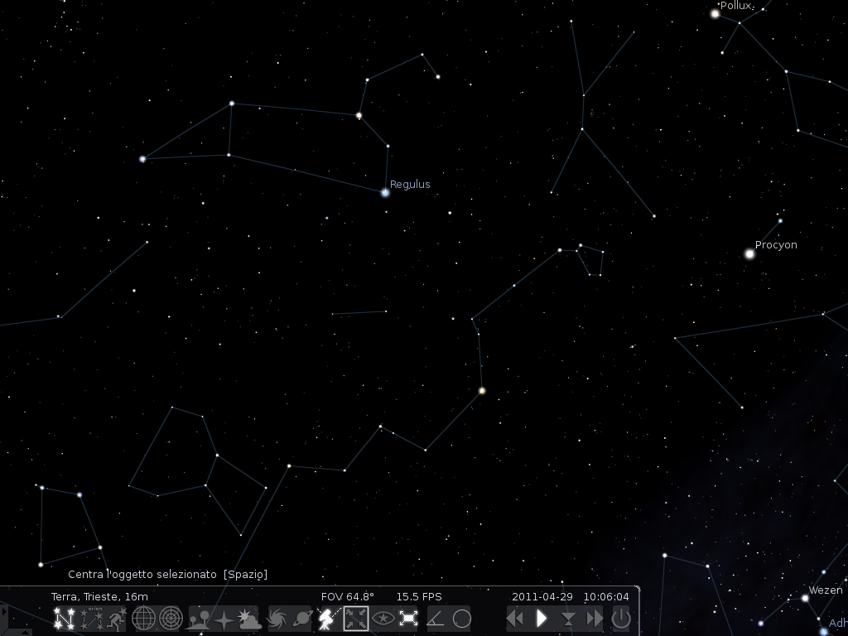) in order to have the ecliptic fixed at the centre of the screen.

Stellarium has also a useful plugin that allows to compute angular distances. We activate it from *configuration window -> plugins -> angle measure*. Select “load at start-up”: at the next start up of Stellarium the button (Nuova immagine (8)) will appear in the bottom menu.

In order to measure the semi-major axis of Io’s orbit, we accelerate the time and observe Io’s revolution around Jupiter. We stop the time when Io is at its maximum distance from Jupiter. Now we should measure the distance between the center of Jupiter and the center of Io. Since it is quite difficult to accurately locate the center of Jupiter, a good solution is to measure the angular separation from Io to the limb of Jupiter and then subtract the radius of the planet (fig. 2).



Fig. 2: Measurement of the angular separation between Jupiter and Io using the “angular measure” tool of Stellarium.

Note: the value of the angular separation can vary a little depending on the epoch of the observations: the distance of Jupiter from Earth is not constant.

The angular separation (*d*) between Jupiter and Io is *d* = 0° 1’ 51” – Jupiter radius (we select Jupiter and read the diameter in the data provided by Stellarium, the radius is half diameter) = 0° 1’ 51” – 0° 0’ 16” = 0° 1’ 35” = 4,606 · 10-4 rad.

Now, in order to compute the semi-major axis (*a*) of the Io’s orbit, we need the distance of Jupiter from us (*D*): we read it in Stellarium (6,10 AU. AU = astronomical unit = 150000000 km).

*a* = *d* · *D =* 4,606 · 10-4 rad · 6,10 AU = 2,81 · 10-3 AU = 421449000 m

In order to measure the revolution period of Io, we suggest to write down the epoch in which Io touches the limb of Jupiter (it is tangent to Jupiter – fig. 3), then we accelerate the time, follow the orbit of Io around Jupiter and write down the epoch in which we see a second time the same configuration (Io tangent to the limb of Jupiter after a revolution). The difference between the two epochs corresponds to the revolution period of Io.



Fig. 3: Example of start point for the computation of the revolution period of Io around Jupiter.



Fig. 4: Example of end point for the computation of the revolution period of Io around Jupiter.

Looking at figures 3 and 4: period (*P*) = 2013, June 4 at 22:43:25 – 2013 June 3 at 04:12:48 = 42 h 30 m 37 s = 153037 s.

Now we have all the data we need to compute the Mass of Jupiter from the general formulation of the third Kepler’s law:

$$\begin{aligned}P_{\text{Io}}^{2}=\frac{4⋅π^{2}}{G⋅M_{\text{Jup}}}⋅a_{\text{Io}}^{3} \\ ⇓ \\ M_{\text{Jup}}=\frac{4⋅π^{2}⋅a_{\text{Io}}^{3}}{G⋅P_{\text{Io}}^{2}}= \\ \frac{4⋅π^{2}⋅(\text{421449000}m)^{3}}{6,\text{67}⋅{\text{10}}^{-\text{11}}m^{3}{\text{kg}}^{-1}s^{-2}⋅(\text{153037}s)^{2}}= \\ 1,\text{89}⋅{\text{10}}^{\text{27}}\text{kg}\end{aligned}$$

With the aim to obtain a more accurate result, or to verify that we just obtained, we can compute the mass of Jupiter using data from the other three Galileian moons (Europa, Ganymede and Callisto) and then compute the average of the measured values as the final result.



*We thank Alessia Canelli, Karin Cescon, Dimitri Francolla and Asia Micheli, from liceo scientifico G. Galilei in Trieste, for the review of this use case done in the framework of the european project Asterics (H2020).*