
Drawing joint ANTARES and IceCube high energy event skymap in TopCAT
V. Kulikovskiy (CPPM, Marseille)
23 June 2016

What’s this about?
Here the example how to plot different Virtual Observatory (VO) tables containing entries with positions on the sky using TopCAT are shown . Preselection of table entries is done. Different event plotting styles are shown based on whether coordinates have uncertainties or not.
The VO tables used in this manual are related to the two event lists from the ANTARES and the IceCube neutrino telescopes. Such detectors reconstruct neutrino events thanks to the Cherenkov light emitted during the neutrino interaction products (muons, hadronic/electronic showers) propagation in the transparent medium (water/ice). The event information provided contains coordinates of the reconstructed neutrino origins on the sky. Additionally, position uncertainties, neutrino energy estimation and the event time may be provided.

Whole tables download using TAP service
Different data retrieval methods from the VO are provided including the cone searches and Table Access Protocol (TAP) service. Here the TAP service is used to get the whole data tables. To download each table perform the following operations:
- Open TAP query window VO->Table Access Protocol (TAB) Query.
- Find the service where the data is stores. Search for keywords (just one is enough as they both are stored in the same place):
  - “Antares” (found in GAVO DC TAP -> antares10.data),
  - “IceCube” (found in GAVO DC TAP -> icecube.nucand).
- Double click on the table. Find it again in the opened tab “Use Service”.
  - Select antares10->antares10.data.
  - Check the table variables by choosing “Columns” tab. This gives you description of the variables used (as later only variable names will appear from which it is not always obvious to guess their meaning).
Check that there are the following variables:
- raj2000, dec2000 which are equatorial coordinates,
- ang_error which is 1 sigma confidence radius of the position,
- n_hits that means “Number of signals from the photo multiplier tubes contributing to this observation.”
  - Click in the bottom on Examples->Basic->Full Table.
    - The query “SELECT TOP 1000 * FROM antares10.data” should appear.
    - Modify the query to get more than 1000 entries (3092 events are provided in this table actually) “SELECT TOP 10000 * FROM antares10.data”.
    - Run Query.
    - New Table in the TopCAT main window should appear. Check that its size is less than requested number of items to be sure that the whole table is downloaded (3092 rows are shown).
- Come back to the TAP window to find “icecube->icecube.nucand” table and repeat the same steps as for the ANTARES table (there are 12876 events in this table).
  - Check also that “nualpha” and “nudelta” are RA and DEC equatorial coordinates and mue is “Estimated muon energy at closest distance to the center of the IceCube detector” in GeV.
- If some downloaded tables are wrong or not complete they may be deleted from the TopCAT main window (File -> Discard Table(s)).
- Explore the tables by double clicking on them in the main window.

Data distributions study
To select limited number of high energy events one needs to study the energy distributions first. To plot the n_hits and mue from ANTARES and IceCube table, correspondingly, select one of the table and click in the main menu Graphics->Histogram Plot or simply button.
For ANTARES data: select Table “TAP_#_antares10.data” and X “n_hits”. For IceCube select table “TAP_#_icecube.nucand” and X “mue”. Go to “Axes” to select X Log and Y log for the last histogram. The appearing plots should be similar to the ones reported in Figure 1.
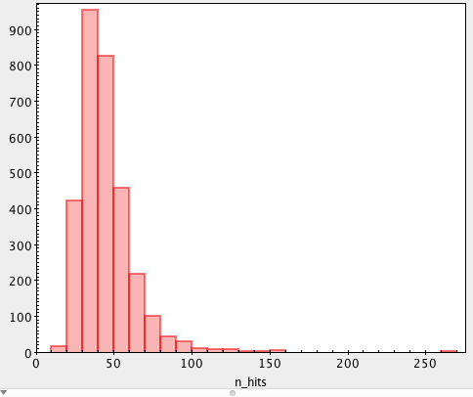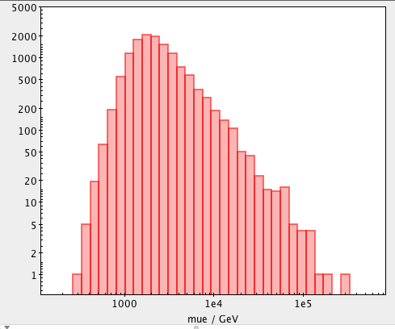
Figure 1 ANTARES events Nhit distribution (left) and IceCube Emu distribution (right).

Events selection
- Select ANTARES table and click in the main menu “Views->Row Subsets” or simply button.
- Click , type clear subset name (it will appear as a histogram label after). For example, “ANTARES Nhit>100”.
- Add selection “n_hits>100” (this selection was chosen to select the tail for the Nhit distribution shown in Figure 1).
- For the IceCube data add two selections (mue > 5e4 and 1e5).

Plotting skymap
- In the main menu Graphics->Sky Plot or simply button.
- Select ANTARES table first and go to Subset to select high energy events only.
- Choose and ang_error as Primary Radius to plot angular errors as cirles.
- Choose “aitoff” projection in “Axes”.
- Add IceCube tables with buttion (plot them as dots only as no errors are provided).
- Adjust colors and styles of each subset in the “Form” tab. Subset Styles frame can be used to adjust one subset only instead of the global settings.
- Eventually adjust the Legen location (Legend->Location->Internal and after you can move it in the fram below).
- An example of the final results is reported in Figure 2. Use Export menu button (.png extension was used).
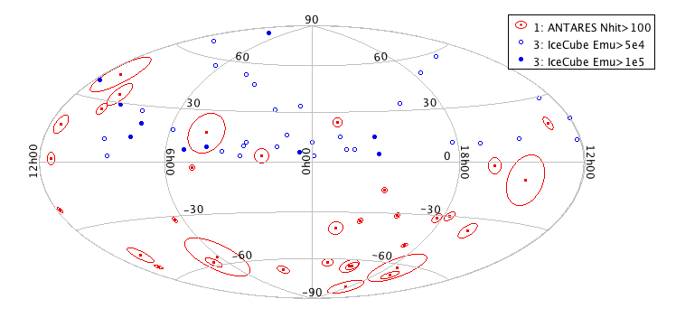
Figure 2. ANTARES and IceCube high energy events skymap in equatorial coordinates.

